1. Write a function that to calculate BMI (Body Mass Index): BMI for a person is defined as their body mass divided by the square of their height. The weight is in kilograms and the height in meters or (The weight can be in pounds and the height in inches) \* 703. Check your BMI:

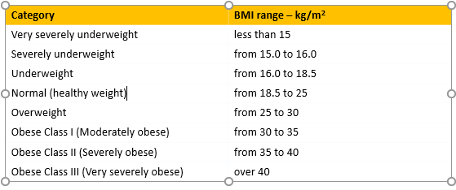

Sol:-

BMI=function (m,h){m/h^2}

BMI(1:100,1:3)

[1] 1.0000000 0.5000000 0.3333333 4.0000000 1.2500000 0.6666667 7.0000000 2.0000000

[9] 1.0000000 10.0000000 2.7500000 1.3333333 13.0000000 3.5000000 1.6666667 16.0000000

[17] 4.2500000 2.0000000 19.0000000 5.0000000 2.3333333 22.0000000 5.7500000 2.6666667

[25] 25.0000000 6.5000000 3.0000000 28.0000000 7.2500000 3.3333333 31.0000000 8.0000000

[33] 3.6666667 34.0000000 8.7500000 4.0000000 37.0000000 9.5000000 4.3333333 40.0000000

[41] 10.2500000 4.6666667 43.0000000 11.0000000 5.0000000 46.0000000 11.7500000 5.3333333

[49] 49.0000000 12.5000000 5.6666667 52.0000000 13.2500000 6.0000000 55.0000000 14.0000000

[57] 6.3333333 58.0000000 14.7500000 6.6666667 61.0000000 15.5000000 7.0000000 64.0000000

[65] 16.2500000 7.3333333 67.0000000 17.0000000 7.6666667 70.0000000 17.7500000 8.0000000

[73] 73.0000000 18.5000000 8.3333333 76.0000000 19.2500000 8.6666667 79.0000000 20.0000000

[81] 9.0000000 82.0000000 20.7500000 9.3333333 85.0000000 21.5000000 9.6666667 88.0000000

[89] 22.2500000 10.0000000 91.0000000 23.0000000 10.3333333 94.0000000 23.7500000 10.6666667

[97] 97.0000000 24.5000000 11.0000000 100.0000000